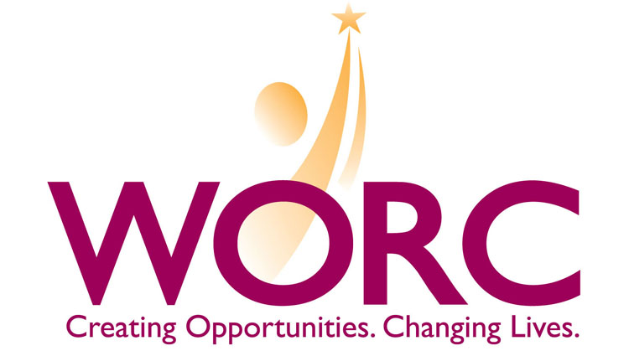

2010 Chestnut Street
Philadelphia, PA 19103
Telephone: (215) 564-5500•Facsimile: (215) 564-0933
Website: www.worc-pa.com

JOB TITLE: Director of Lending and Training

REPORTS TO: President

OVERVIEW: The Women’s Opportunities Resource Center (WORC) is a nationally-recognized not-for-profit organization headquartered in Philadelphia. WORC promotes social and economic self-sufficiency primarily for women, minorities, and dislocated workers. Its subsidiary company, the Economic Opportunities Fund (EOF), is a certified CDFI which provides a wide range of financial products (microloans from $1,000 to $50,000). Our loan fund is capitalized at $2.2 million. To date, we have made a total of 568 direct loans totaling over $2.4 million. In addition, we have packaged 45 loans totaling more than $1.1 million as an intermediary for the SBA Prequalification Program. WORC is an SBA microlender and recently received a highly competitive CDFI grant and was one of ten organizations nationwide to receive the ORR Microenterprise grant for Microlending and training with refugees.

EOF’s goal is to expand its market base and increase its loan volume and capital deployed. We are looking for a professional that is committed to meeting the needs of this underserved market, has demonstrated experience scaling a microenterprise organization and is comfortable with providing services to a diverse population, including refugees and immigrants.

A strong background in micro and small business financing is required. Experience in Consumer Finance is a plus. Must be comfortable with use of technology platforms.

RESPONSIBILITIES:
- Manages and grows the Direct Lending Program including staff and consultant supervision, program marketing, new product development, portfolio performance, asset/liability management, financial projections and assumptions, underwriting, loan servicing, collections, community partnerships and program evaluation.
- Responsible for loan portfolio quality and performance. Ensures compliance with portfolio standards e.g. that PAR 90 day + is less than 12% and annual write-off below 9%. Implements and monitors credit risk program including risk rating as well as identifying, measuring, controlling, monitoring the risks with periodic reporting to senior management and Board.
- Coordinates and plans the Advisory Council and Loan Committee meetings by setting the agenda, preparing reports and documents, and conducting the meetings
- Oversees training and TA services to ensure quality service and compliance with contract goals.
- Responsible for grant compliance and reports as needed for funders, Advisory Council or Board of Directors.
- Member of senior management team - develops and implements EOF business plan/marketing plan.
- Fundraising and capitalization - writes grants and secures funding and assists with implementing WORC’s overall fundraising strategy.
- Performs other related duties as required.

Salary is competitive based on experience and applicable skills. Benefits include: vacation, paid holidays, health insurance and pension plan. WORC/EOF is an equal opportunity employer and the board and staff value diversity in all aspects of employment. Interested candidates should send resumes and salary requirements to careers@worc-pa.com.

